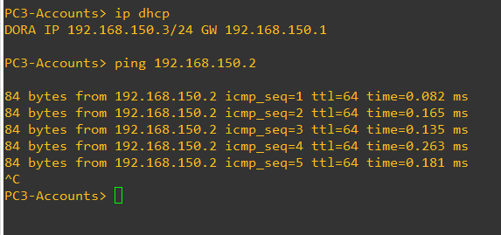Able to ping one another on the vlan

Pinging to another VPC in the same VLAN (VLAN 150)

Pinging to another VPC in a different VLAN (VLAN 100 -> 150)

Packet capture Pinging different VLAN

The first 2 ARP packets are the PC’s looking for the router gateway of its VLAN.

Following that, (with some failed pings due to timeout), the PC on VLAN-100 pings the second PC on VLAN-150, requesting that it